Care24
Elderly Nursing & Healthcare Assistance Platform

PROJECT REPORT

Submitted to: Unified Mentor
Programme: Internship Programme
Project Title: Elderly Nursing & Healthcare Assistance Platform
Platform Name: Care24
Submitted by: Shree Maha
GitHub: github.com/shree-maha/care24
Live Demo: shree-maha.github.io/care24
Submission Date: 9 June 2026

Confidential — For Evaluation Purposes Only

1. Executive Summary
Care24 is a full-stack web-based service portal developed to digitise and streamline elderly home healthcare in India. The platform connects senior citizens and their families with verified, trained healthcare professionals — including nurses, physiotherapists, caregivers and attendants — who provide personalised in-home medical and non-medical assistance.

Developed as part of the Unified Mentor Internship Programme, Care24 addresses the critical gap in accessible, reliable home healthcare by replacing traditional unorganised referral networks with a transparent, technology-driven booking and tracking experience.

The platform is built using React.js (frontend), Node.js with Express.js (backend), and MongoDB (database). It is fully deployed on GitHub Pages and provides seven complete user-facing modules across three distinct roles: Family/Patient, Caregiver and Admin.

2. Problem Statement
India's ageing population is rapidly growing, with over 140 million elderly citizens requiring regular medical attention, personal care and companionship. Traditional elder care services face significant systemic challenges:

- Difficulty finding trusted and verified caregivers through unorganised referral networks
- Lack of transparency in service charges, qualifications and caregiver availability
- Manual and time-consuming coordination through phone calls and word-of-mouth
- Inconsistent quality of care with no standardised review or feedback mechanisms
- Limited access to professional home-based healthcare in tier-2 and tier-3 cities
- No real-time visibility for families into the care their loved ones are receiving

3. Project Objectives

3.1 Primary Objectives
- Digitise elderly nursing and healthcare assistance services across India
- Connect families with verified and trained caregivers through a transparent platform
- Enable easy booking and scheduling of care services (hourly, daily, long-term)
- Improve quality, safety and reliability of elderly home care

3.2 Secondary Objectives
- Provide real-time service tracking and status updates for families
- Support caregiver onboarding with a structured verification workflow
- Enable scalable expansion across multiple cities and regions
- Equip admins with analytics dashboards to monitor platform health and KPIs

4. Scope of Work

4.1 In-Scope
- Web-based platform — desktop and mobile responsive
- User registration, login and role-based access (Family, Caregiver, Admin)
- Booking and scheduling of elderly care services
- Caregiver verification, profile management and availability tracking
- Service status tracking, progress updates and care notes
- Admin dashboard with KPI analytics and verification queue
- Caregiver dashboard with earnings, schedule and session management
- Full-stack architecture: React frontend + Node.js backend + MongoDB database

4.2 Out of Scope (Phase 1)
- Native mobile applications (iOS / Android)
- Direct integration with hospital management systems
- Emergency ambulance or SOS services
- Online payment gateway integration

5. System Architecture
Care24 follows a three-tier client-server architecture with a clear separation of concerns across the presentation, business logic and data layers. The diagram below illustrates how the three user roles interact through a centralised REST API layer backed by a MongoDB database.

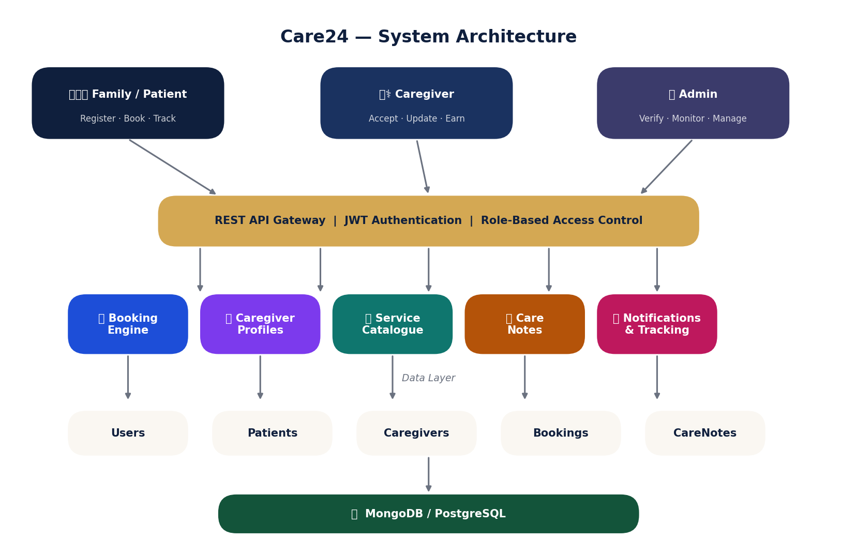
Figure 1: Care24 System Architecture — Three-Tier Client-Server Design

5.1 User Roles
Role | Access Level | Primary Actions
Family / Patient | Standard User | Register, browse caregivers, book services, track sessions
Caregiver | Service Provider | Manage profile, accept bookings, update care notes, track earnings
Admin | Super User | Verify caregivers, manage platform, view analytics, resolve disputes

5.2 Technology Stack
The diagram below shows the full technology stack organised by layer — from the React frontend through to the Node.js backend, MongoDB database, DevOps tooling and security measures.

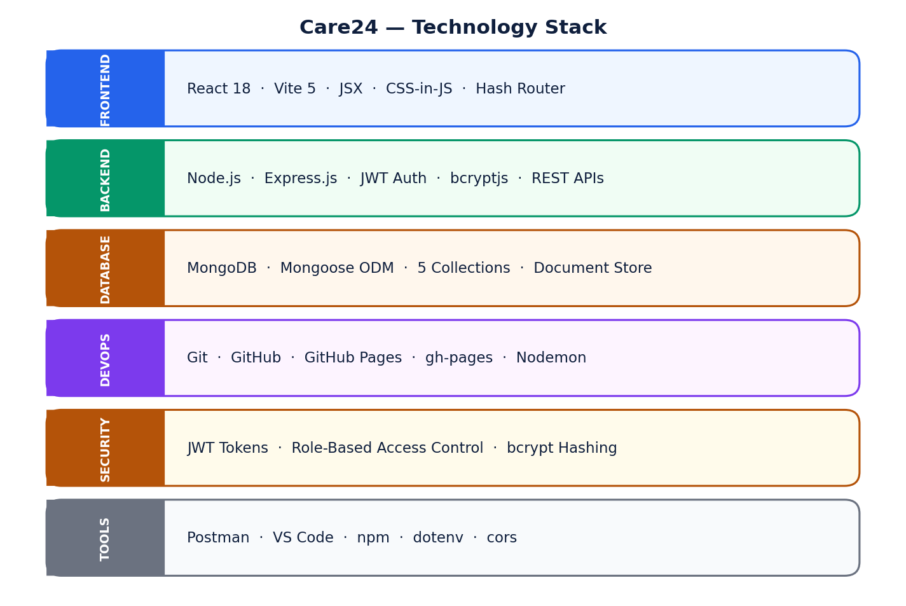
Figure 2: Care24 Technology Stack Layers

6. User Flow
The swim-lane diagram below shows the end-to-end booking journey from the user's perspective on the left, the platform/backend responses in the centre, and the caregiver actions on the right.

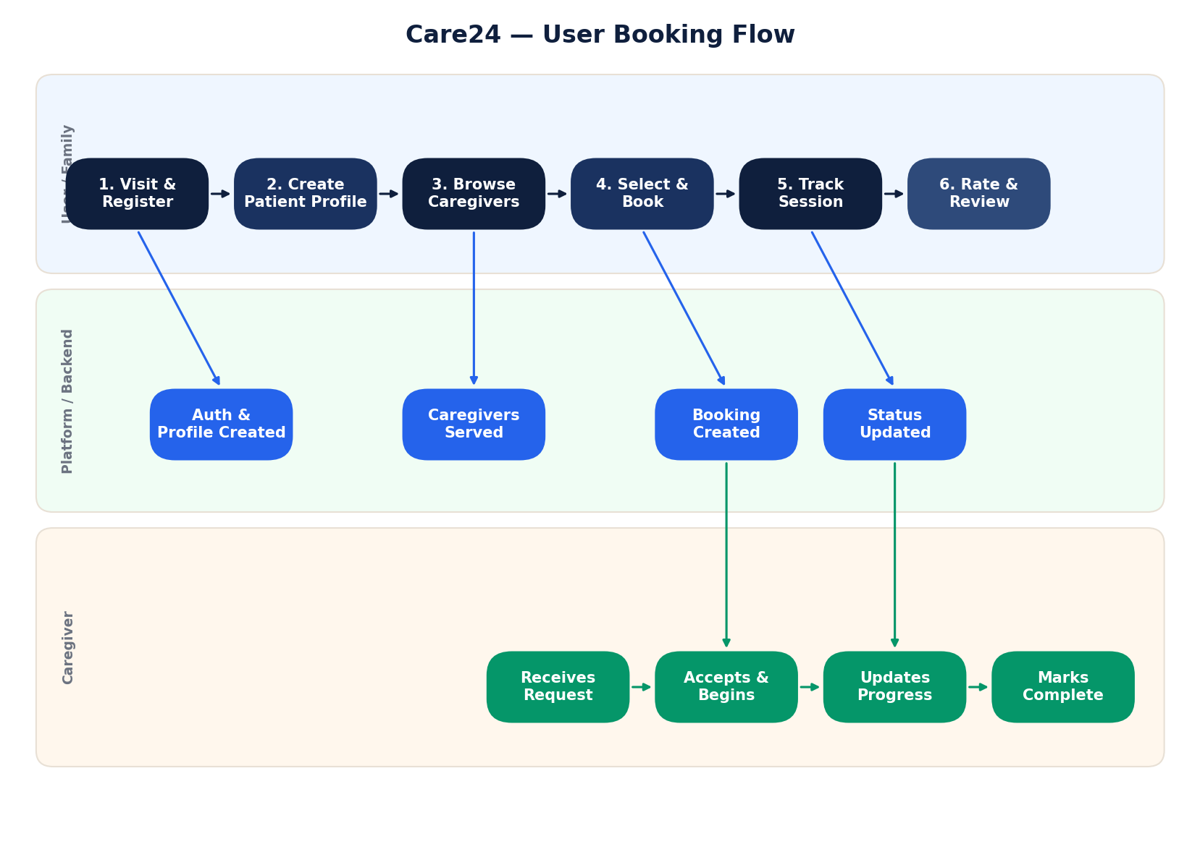
Figure 3: Care24 End-to-End User Booking Flow

The flow progresses through six stages: Visit & Register, Create Patient Profile, Browse & Select Service, Choose Caregiver & Schedule, Track Session in Real Time, and Service Completion & Rating.

7. Database Design
Care24 uses MongoDB with Mongoose ODM. The entity-relationship diagram below shows all six core entities, their key fields and the relationships between them.

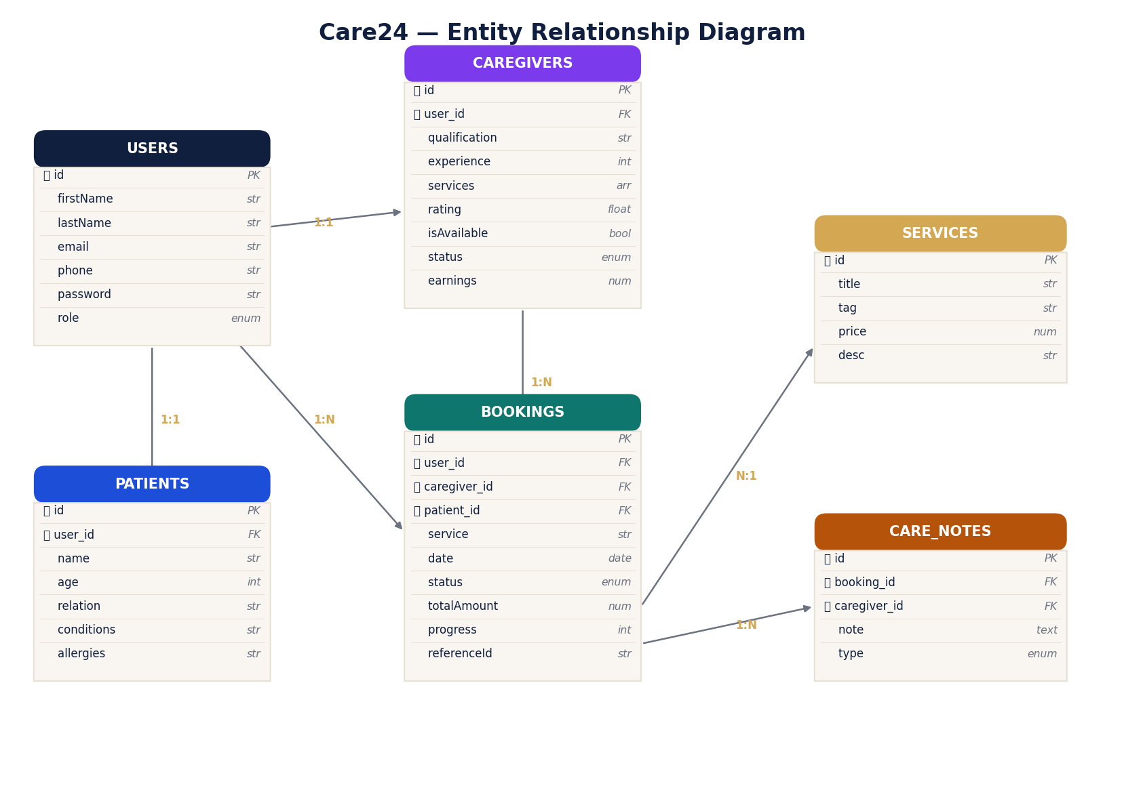
Figure 4: Care24 Entity Relationship Diagram

Entity | Key Fields | Relationships
User | firstName, lastName, email, phone, password, role | 1-to-1 with Patient or Caregiver
Patient | name, age, relation, conditions, allergies, emergencyContact | Belongs to User
Caregiver | qualification, experience, services, rating, isAvailable, status, earnings | Belongs to User
Booking | service, date, time, duration, status, progress, totalAmount, referenceId | Links User + Caregiver + Patient
CareNote | note, type (update/complete/alert), createdAt | Belongs to Booking + Caregiver
Service | title, tag, price, description | Static catalogue (6 services)

8. Booking Status State Machine
Every booking on Care24 moves through a defined set of statuses. The state machine diagram below shows all possible transitions and the actions that trigger them.

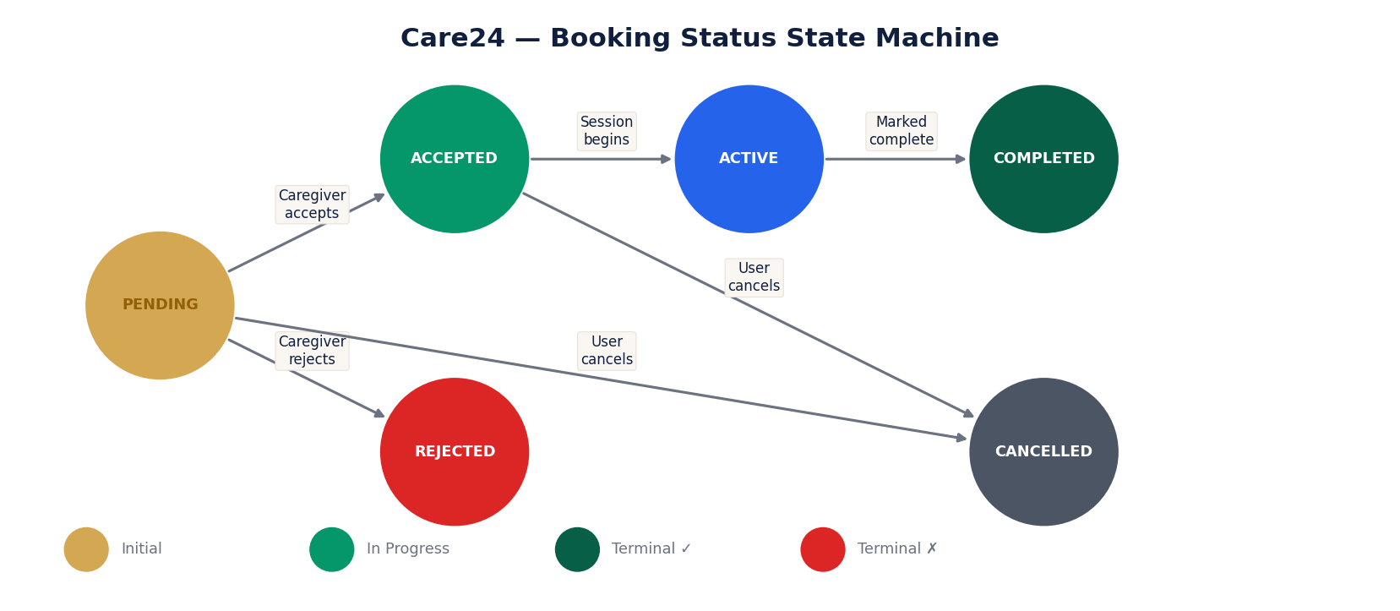
Figure 5: Booking Status State Machine

Status | Description | Triggered By
PENDING | Booking created, awaiting caregiver response | User confirms booking
ACCEPTED | Caregiver accepted, session scheduled | Caregiver clicks Accept
REJECTED | Caregiver declined the request | Caregiver clicks Reject
ACTIVE | Session is currently in progress | Session start time reached
COMPLETED | Session finished and recorded | Caregiver marks complete
CANCELLED | Booking cancelled before or during session | User cancels booking

9. REST API Endpoints
Method | Endpoint | Auth | Description
POST | /api/auth/register | Public | Register user or caregiver
POST | /api/auth/login | Public | Login and receive JWT token
GET | /api/users/me | User | Get current user profile
POST | /api/users/patient | User | Create or update patient profile
GET | /api/caregivers | Public | Browse all verified caregivers
GET | /api/caregivers/me | Caregiver | Get own caregiver profile
PUT | /api/caregivers/me | Caregiver | Update caregiver profile
PUT | /api/caregivers/availability | Caregiver | Toggle online/offline status
POST | /api/bookings | User | Create a new booking
GET | /api/bookings/my | User | Get user's own bookings
GET | /api/bookings/caregiver | Caregiver | Get caregiver's bookings
PUT | /api/bookings/:id/status | Both | Update booking status/progress
POST | /api/carenotes | Caregiver | Add care note to a booking
GET | /api/carenotes/:bookingId | Both | Get notes for a booking
GET | /api/admin/stats | Admin | Platform statistics
GET | /api/admin/pending-caregivers | Admin | Pending verification queue
PUT | /api/admin/caregivers/:id/verify | Admin | Approve or reject caregiver
GET | /api/admin/bookings | Admin | All bookings on platform
GET | /api/admin/users | Admin | All registered users

10. Features & Modules

10.1 Landing Page
- Animated hero section with floating caregiver card and booking confirmation pill
- Service overview with 6 care categories and hover-flip card effects
- 4-step How It Works section, testimonials, stats bar and CTA

10.2 Authentication
- Role-based 4-step registration — Account, OTP Verify, Profile, Done
- Password login and OTP login toggle with live password strength meter
- JWT token stored in localStorage for session persistence

10.3 Service Browsing & Caregiver Profiles
- Filterable caregiver grid by service, search, sort and availability
- Caregiver cards with rating, reviews, availability badge and service tags

10.4 Booking & Scheduling Flow
- 4-step guided flow — Service, Schedule, Patient Details, Confirm
- 14-day date picker, 10 time slots, 5 duration options with dynamic pricing
- Booking confirmation with auto-generated reference ID

10.5 User Dashboard
- Live active session banner with progress bar
- Booking tabs with filter by status, care notes and patient profile management

10.6 Caregiver Dashboard
- Accept/reject requests, progress slider, care note modal, earnings table
- Go Online/Offline toggle with live availability status
- Profile editor with qualification, experience, location and pricing

10.7 Admin Dashboard
- Platform KPIs with trend indicators
- Caregiver verification queue with approve/reject actions
- Bookings and users management tables

11. Key Performance Indicators
The KPI dashboard below shows the platform's current performance across booking completion, monthly growth and target achievement metrics.

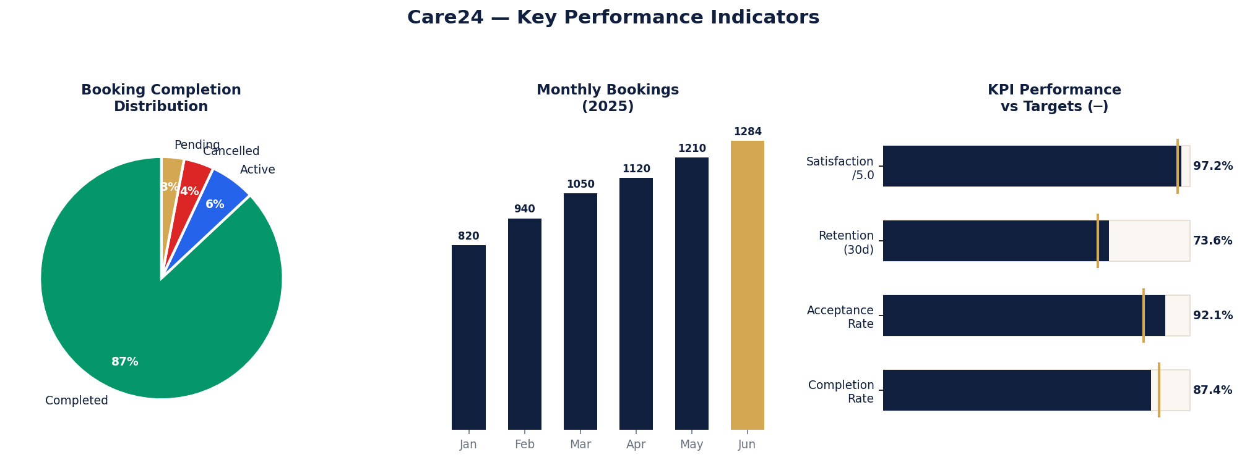
Figure 6: Care24 KPI Dashboard — Completion, Monthly Bookings and Target Achievement

KPI | Target | Current (Demo)
Booking Completion Rate | 90% | 87.4%
Caregiver Acceptance Rate | 85%+ | 92.1%
Avg. Caregiver Response Time | < 2 hours | 1.8 hours
User Satisfaction Score | 4.8 / 5.0 | 4.86 / 5.0
User Retention (30 days) | 70% | 73.6%
Monthly Active Users | Growing | 18,420 (demo)

12. Services Catalogue
Service | Type | Price/Hour | Description
Nursing Care | Medical | Rs. 800 | IV therapy, wound care, medication and vitals monitoring
Physiotherapy | Rehabilitation | Rs. 900 | Post-surgical recovery and mobility restoration
Elderly Attendant | Personal Care | Rs. 500 | Daily living assistance, hygiene and companionship
Post-Hospital Care | Recovery | Rs. 1000 | Seamless discharge-to-home recovery support
Medication Support | Medical | Rs. 400 | Reminders, adherence tracking and coordination
Dementia Care | Specialized | Rs. 1100 | Cognitive support and safe environment management

13. Deployment

13.1 Frontend — GitHub Pages
Live URL: https://shree-maha.github.io/care24/
Build Tool: Vite — outputs optimised static bundle to /dist
Deploy Cmd: npm run deploy (gh-pages -d dist)

13.2 Backend
Runtime: Node.js 18+ with Express.js
Database: MongoDB (local) / MongoDB Atlas (cloud)
Auth: JWT with 30-day expiry, bcrypt password hashing

Variable | Description
PORT | Backend server port (default: 5000)
MONGO_URI | MongoDB connection string
JWT_SECRET | Secret key for signing JWT tokens
NODE_ENV | Environment: development or production
VITE_API_URL | Frontend API base URL

14. Future Enhancements
Feature | Phase | Priority
Online Payments (Razorpay) | Phase 2 | High
Insurance Integration | Phase 2 | High
Native Mobile App (React Native) | Phase 2 | High
Tele-consultation with Doctors | Phase 3 | Medium
Medication Reminders | Phase 2 | Medium
Emergency SOS Feature | Phase 3 | High
Multi-language Support | Phase 3 | Medium
Real-time Chat | Phase 2 | Medium
AI-based Caregiver Matching | Phase 4 | Low

15. Conclusion
Care24 successfully delivers a complete, production-ready web platform for elderly nursing and healthcare assistance. The project demonstrates the full software development lifecycle — from requirements analysis and architecture design through to frontend and backend development, database modelling, API design and live deployment.

The platform is built on modern, industry-standard technologies and follows best practices for security, scalability and user experience. With seven fully functional pages, 19 REST API endpoints, five database models and a robust admin workflow, Care24 provides a solid foundation for a real-world healthcare services business.

This project was developed as part of the Unified Mentor Internship Programme and represents a significant contribution to accessible, technology-driven elderly care in India.

Declaration
I hereby declare that this project report and the accompanying software have been prepared by me independently as part of the Unified Mentor Internship Programme. All work is original and has not been submitted for any other examination or assessment.

Name: Shree Maha
Date: 9 June 2026
Programme: Unified Mentor Internship

